LARYNGOSTROBOSCOPY (according to SIFEL Protocol)

Surname _____________________________ Name___________________

Endoscopy typology: Rigid endoscope 70° Rigid endoscope 90° Flexible endoscope

Pitch _______Hz Loudness_________dB Vocal register ________________

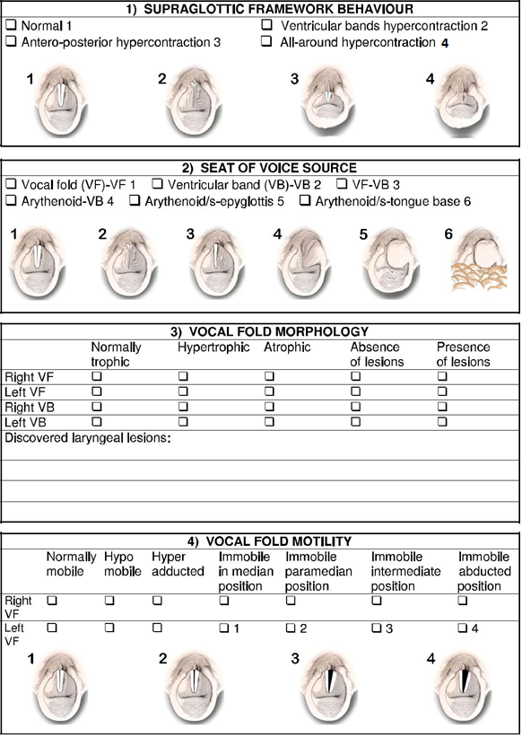

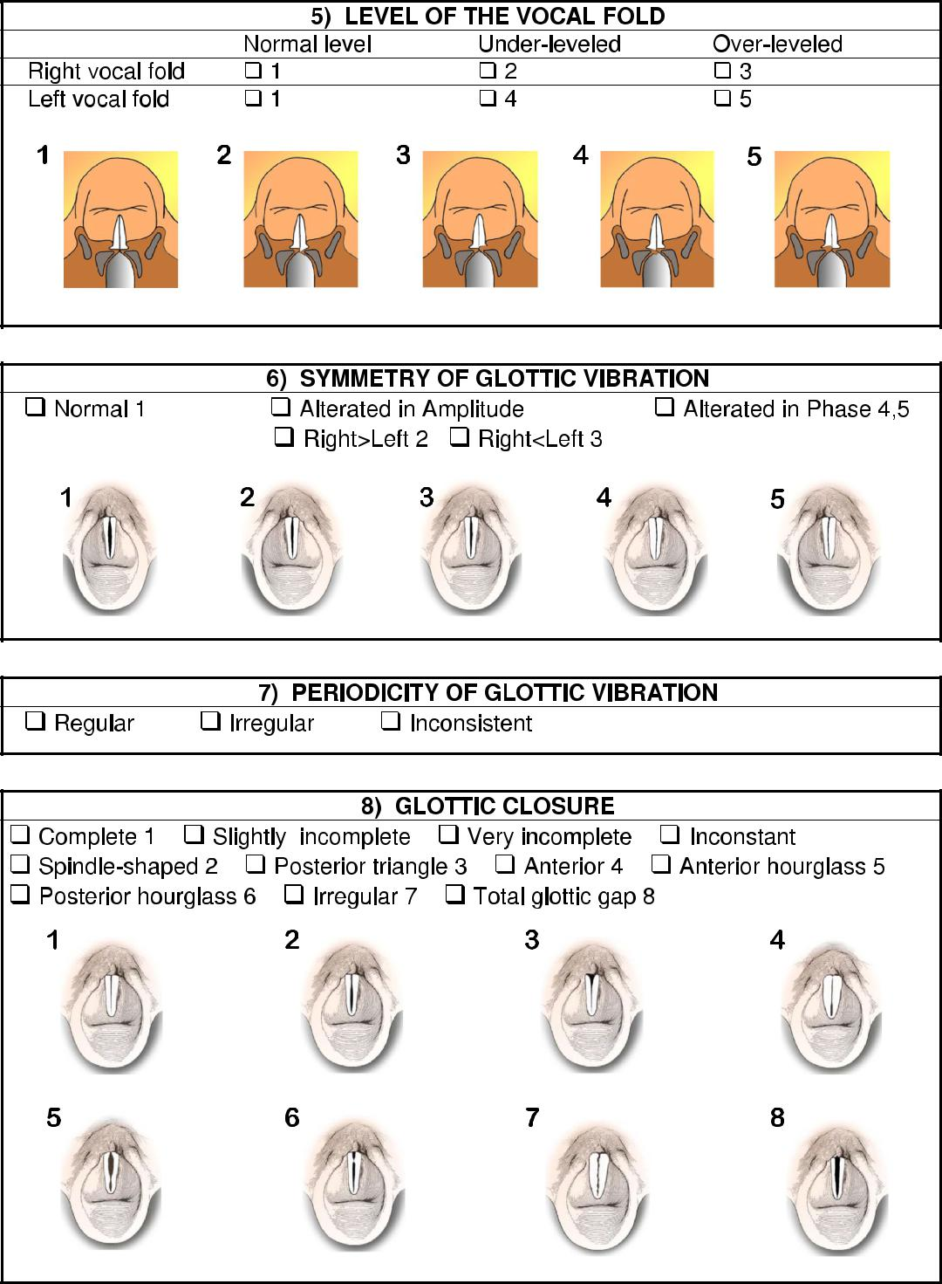

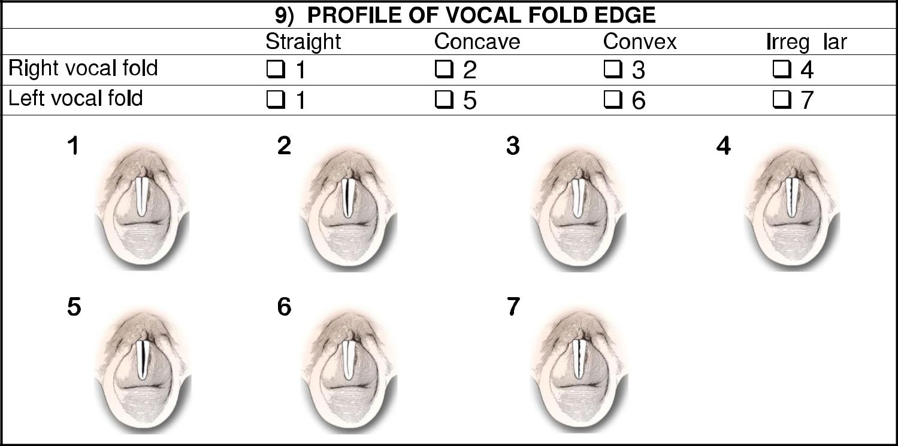

u

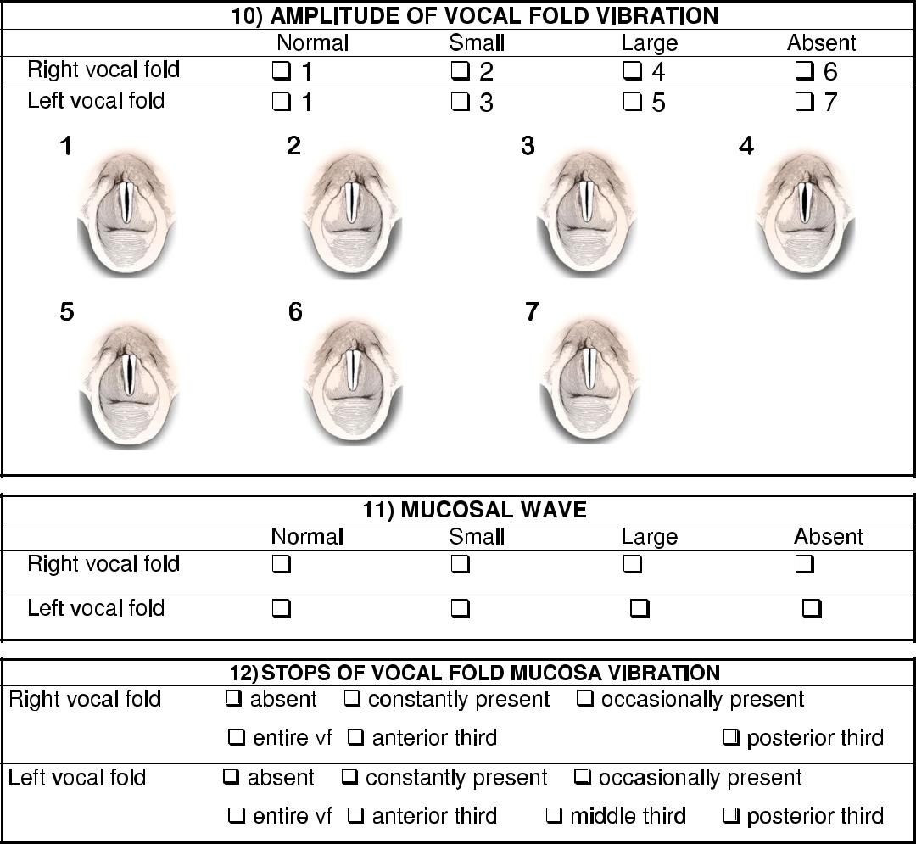

middle third

__________________________________________________________________________________________________

